Fuiou Cross-border Payment Gateway API
Ver. 1.00



上海富友支付服务有限公司
Shanghai Fuiou Payment Service Co., Ltd.

Version Information
Version | Date | draft and revise | Info
1.00 | 2011-03-23 | Wei Xiaomin

The whole contents in this document are confidential information and owned by Shanghai Fuiou Payment Service Co., Ltd. Without the explicit written permission of Shanghai Fuiou Payment Service Co., Ltd., any organization or individual mustn’t copy or disseminate some or all of the contents by any destination, any form or any way.

Contents
1 Overview 3
1.1 Purposes 3
1.2 Definitions 3
2 Diagram of Transaction Flow 3
3 API Introduction 3
3.1 B2C/B2B Payment 3
3.1.1 Inputs in API 3
3.1.2 MD5 Description 5
3.1.3 Outputs in API 5
3.1.4 Example for Outputs 6
3.2 Query of Payment Result (Return directly) 7
3.2.1 Inputs in API 7
3.2.2 MD5 Description 7
3.2.3 Example for Inputs 8
3.2.4 Outputs in API 8
3.3 Refund Order 9
3.3.1 Inputs in API 9
3.3.2 MD5 Description 10
3.3.3 Example for Inputs 10
3.3.4 Outputs in API 10
3.3.5 Example for Outputs 10

Overview

Purposes
This specification is written for the merchant developers who use Fuiou Cross-border Online Payment Service. The merchant can use this API to send payment to Fuiou Cross-border Payment Gateway.

Definitions
In this specification, the following expressions shall have the following meanings:
Fuiou System: shall mean Fuiou Cross-border Payment Gateway.

Diagram of Transaction Flow
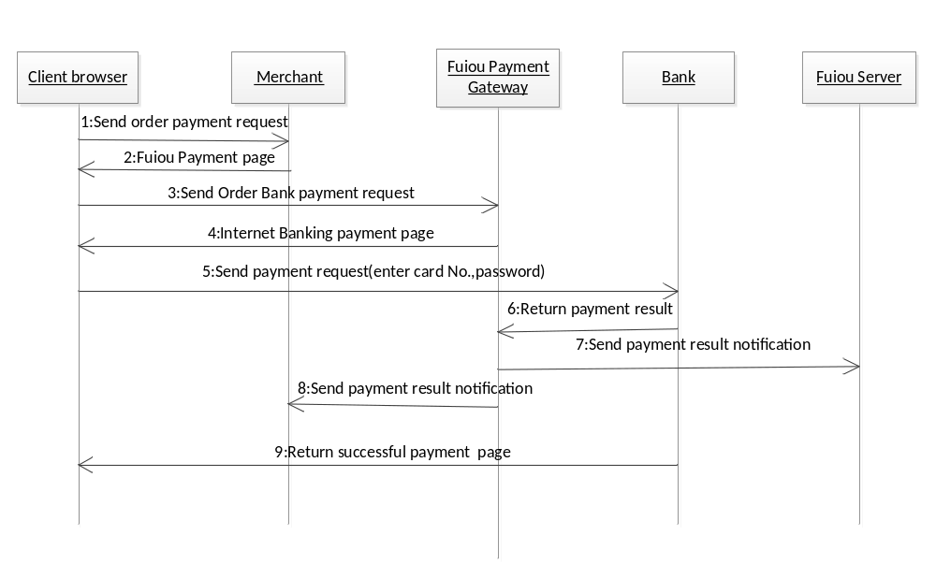

API Introduction

B2C/B2B Payment

Inputs in API
Merchant website shall send Fuiou system the variables and values as shown in the table below.
Note: The payment information is submitted to Fuiou System through form. The submitted method must be post, and the charset must be UTF-8.
Submit Address：https://pay.fuiou.com/newSmpGate.do

Variable Name | Corresponding FORM Domain | Length | Parameter Description | Required or Not | Example
Merchant Id | mchnt_cd | 15 | It is an unique identified id assigned to each merchant by Fuiou. | Required | 0002900F0006944
Merchant Order Id | order_id | MAX(30) | The unique order id is generated by merchant’s website after customer buy, and it should be unique, not same with others. Fuiou verifies an order uniquely by it. | Required | 11032302065863805732
Transaction Amount | order_amt | MAX(12) | The total amount that customer pay for the order, and the unit is cent. It must not be zero. | Required | 2000
Currency | cur_type | 3 | It is transaction currency published by merchant website. | Required | Supported currently：  China: CNY  United States: USD  Hong Kong: HKD  Macao: MOP  Europe: EUR  Korea: KRW  Japan: JPY  Singapore: SGD  Australia: AUD
Payment Type | order_pay_type | 3 | Set ‘B2C’ fixed. | Required | B2C
the URL of Jumping Page | page_notify_url | MAX(200) | It is the URL which merchant receives the payment result. | Required | http://192.168.9.7:8080/paytest/result.jsp
the URL of Background Notification | back_notify_url | MAX(200) | It is the URL of background notification which merchant receives payment result. | Not required | http://192.168.9.7:8080/paytest/result.jsp
Valid Time | order_valid_time | 2 | From 1m to15d.  m：Minute  h：Hour  d: Day  1c: Valid on the same day | Not required | 10m
Bank Id | iss_ins_cd | 10 | Set '0000000000' fixed. | Required | 0000000000
Goods Name | goods_name | MAX(60) |  | Required | Sony W5500 TV
URL of Goods | goods_display_url | MAX(200) |  | Not required | http://192.168.9.7:8080/paytest/ goods_display.jsp
Remark | rem | MAX(60) |  | Not required | Remark
Reserved Field | rcvr | MAX(200) |  | Not required | goods unit price# goods amount #traffic expense
Version Id | ver | MAX(10) | Set ‘1.1’ fixed. | Required | 1.1
MD5 Data | md5 |  | cur_type + "|" + mchnt_cd+ "|" + order_id+"|"+order_amt+"|"+order_pay_type+"|"+page_notify_url+"|"+back_notify_url+"|"+order_valid_time+"|"+iss_ins_cd+"|"+goods_name+"|"+"+goods_display_url+"|"+rem+"|"+rcvr+"|"+ver+"|"+mchnt_key  Generate MD5 using the string above, and mchnt_key is merchant key assigned by Fuiou system, which is a 32 bits string. | Required | 2908283de2814a64dc3b9b12e93915bc  The detailed information is descripted in the MD5 summary description next paragraph.

MD5 Description
You shall generate a string with all these fields submitted by form and merchant key assigned by Fuiou system according to the sequence above, and the string should be divided by ‘|’. Then you shall generate a MD5 of this string, and the charset must be UTF-8.

Outputs in API
After customer completing the payment, Fuiou system send http requests to the ‘URL of Jumping Page’ and the ‘URL of Background Notification’ of merchant.
Variable Name | Corresponding FORM Domain | Length | Parameter Description | Required or Not | Example
Merchant Id | mchnt_cd | 15 | It is an unique identified id assigned to each merchant by Fuiou. | Required | 0002900F0006944
Merchant Order Id | order_id | MAX(30) | The unique order id is generated by merchant’s website after customer buy, and it should be unique, not same with others. Fuiou verifies an order uniquely by it. | Required | 11032302065863805732
Order Date | order_date | 8 | YYYYMMDD | Required | 20110322
Transaction Amount | order_amt | MAX(12) | The total amount that customer pay for the order, and the unit is cent. It must not be zero. | Required | 2000
Order Status | order_st | 2 | ‘00’ – Order generated(initial state)  ‘01’ – Order revoked  ‘02’ – Order merged  ‘03’ – Order expired  ‘04’ – Order confirmed (waiting for payment)  ‘05’ –Order payment failed  ‘11’ – Order paid  ‘12’ – Order refunded  ‘18’ – Dispatched  ‘19’ – Confirmed to receive | Required | 11
Error Code | order_pay_code | 4 | 0000 indicates success, others are failure. | Required | 0000
Error Description | order_pay_error | MAX(40) |  | Required | Time out
Reserved Field | resv1 | MAX(40) | Reserved field | Required
Fuiou Serial Id | fy_ssn | 12 | It is used for merchant to inquery transaction record and status. | Required | 000000291642
MD5 Data | md5 |  | cur_type + "|" + mchnt_cd+ "|" + order_id+"|"+order_amt+"|"+order_pay_type+"|"+page_notify_url+"|"+back_notify_url+"|"+order_valid_time+"|"+iss_ins_cd+"|"+goods_name+"|"+"+goods_display_url+"|"+rem+"|"+rcvr+"|"+ver+"|"+mchnt_key  Generate MD5 using the string above, and mchnt_key is merchant key assigned by Fuiou system, which is a 32 bits string. | Required | 2908283de2814a64dc3b9b12e93915bc

Example for Outputs
Assuming the URL of Jumping Page and the URL of Background Notification are as follows:
http://222.88.10.8888/xxx.jsp (The default port number is 80).
After successful payment, Fuiou system will send http request to this address automatically. The requested URL is as follows：
http://222.88.10.8888/xxx.jsp?mchnt_cd=Merchant Id &order_id= Merchant Order Id&order_date=Order Date&order_amt=Transaction Amount&order_st=Order Status &order_pay_code=Error Code&order_pay_error= Error Description&resv1= Reserved Field &fy_ssn= Fuiou Serial Id &md5= MD5 Data

- Merchant website shall extract the MD5 data from the http response after receiving it.
- Merchant website shall extract all the other field values except MD5 data from the http request, then generate a MD5 with these field values and merchant key assigned by Fuiou system.
- Comparing the two MD5 value, case insensitivity, the informed message is valid if equally.

Query of Payment Result (Return directly)

Inputs in API
Variables and values in payment form are defined as shown in the table below.
Note: The payment information is submitted to Fuiou System through form. The submitted method must be post, and the charset must be UTF-8.
Submit Address：https://pay.fuiou.com/newSmpGate.do

Variable Name | Corresponding FORM Domain | Length | Parameter Description | Required or Not | Example
Merchant Id | mchnt_cd | 15 | It is an unique identified id assigned to each merchant by Fuiou. | Required | 0002900F0006944
Merchant Order Id | order_id | MAX(30) | The unique order id is generated by merchant’s website after customer buy, and it should be unique, not same with others. Fuiou verifies an order uniquely by it. | Required | 11032302065863805732
MD5 Data | md5 |  | mchnt_cd + "|" +order_id + "|" + mchnt_key  Generate MD5 using the string above, and mchnt_key is merchant key assigned by Fuiou system, which is a 32 bits string. | Required | 2908283de2814a64dc3b9b12e93915bc

MD5 Description
You shall generate a string with all these fields submitted by form and merchant key assigned by Fuiou system according to the sequence above, and the string should be divided by ‘|’. Then you shall generate a MD5 of this string, and the charset must be UTF-8.

Example for Inputs
The example of querying order:
https://pay.fuiou.com/smpQueryGate.do?md5=d62340b8fb852ec3bb8a8a8f23d4a4e5&mchnt_cd=0002900F0006944&order_id=000001

Outputs in API
<?xml version="1.0" encoding="UTF-8"?>
<ap>
<plain>
<order_pay_code>Error Code (0000 indicates successful, others failed)</order_pay_code>
<order_pay_error>Error Description </order_pay_error>
<order_id>Merchant Order Id </order_id>
<order_st>Order Status (‘00’ – Order generated (initial state)
‘01’ – Order revoked
‘02’ – Order merged
‘03’ – Order expired
‘04’ – Order confirmed (waiting for payment)
‘05’ –Order payment failed
‘11’ – Order paid
‘12’ – Order refunded
‘18’ – Dispatched
‘19’ – Confirmed to receive)</order_st>
<fy_ssn>Fuiou Serial Id</fy_ssn>
<resv1>Reserved Field</resv1>
</plain>
<md5>MD5 Data</md5>
</ap>

MD5 is generated with the fields of plain domain and merchant key, except the tag of plain, as follows:
<order_pay_code> Error Code (0000 indicates successful, other failed)</order_pay_code>
<order_pay_error>Error Description </order_pay_error>
<order_id>Merchant Order Id </order_id>
<order_st> Order Status (‘00’ – Order generated (initial state)
‘01’ – Order revoked
‘02’ – Order merged
‘03’ – Order expired
‘04’ – Order confirmed (waiting for payment)
‘05’ –Order payment failed
‘11’ – Order paid
‘12’ – Order refunded
‘18’ – Dispatched
‘19’ – confirmed to receive)</order_st>
<fy_ssn>Fuiou Serial Id</fy_ssn>
<resv1>Reserved Field</resv1>merchant key

Refund Order

Inputs in API
Variables and values in payment form are defined as shown in the table below.
Note: The payment information is submitted to Fuiou System through form. The submitted method must be post, and the charset must be UTF-8.
Submit Address：https://pay.fuiou.com/newSmpGate.do

Merchant sends request by HttpClient, and payment platform returns refund status directly.
Variable Name | Corresponding FORM Domain | Length | Parameter Description | Required or Not | Example
Merchant Id | mchnt_cd | 15 | It is an unique identified id assigned to each merchant by Fuiou. | Required | 0002900F0006944
Original Transaction Date | origin_order_date | MAX(8) | The transaction date of the refund transaction | Required | 20110411
Original Order Id | origin_order_id | MAX(30) | The Merchant Order Id of refund transaction | Required | 11032302065863805732
Refund Amount | refund_amt | MAX(12) | The refund amount shall be less than original transaction amount and the total successful amount on the same day. | Required | 200
Refund Currency | refund_cur_type | 3 | The default currency is CNY. | Required | 156
Remark | rem | MAX(60) | remarks for refund | Not required | 60
MD5 data | md5 |  | mchnt_cd + "|" + origin_order_date + "|" + origin_order_id + "|" + refund_amt + "|" + refund_cur_type + "|" + rem + "|" + mchnt_key  Generate MD5 using the string above, and mchnt_key is merchant key assigned by Fuiou system, which is a 32 bits string. | Required | 2908283de2814a64dc3b9b12e93915bc

MD5 Description
You shall generate a string with all these fields submitted by form and merchant key assigned by Fuiou system according to the sequence above, and the string should be divided by ‘|’. Then you shall generate a MD5 of this string, and the charset must be UTF-8.

Example for Inputs
Example for refunding:
https://pay.fuiou.com/newSmpRefundGate.do?md5=d62340b8fb852ec3bb8a8a8f23d4a4e5&mchnt_cd=0002900F0006944&origin_order_date =20110411&origin_order_id=11032302065863805732&refund_amt=200&rem=tuikuan

Outputs in API
Variable Name | Corresponding FORM Domain | Length | Parameter Description | Required or Not | Example
Refund Status | order_st | 1 | ‘0’ – accepted  ‘1’ – successful  ‘2’ – failed | Required | 1
Error Code | order_pay_code | 4 | 5341 indicates the refund is successful. | Required | 5341
Error Description | order_pay_error | MAX(40) |  | Required | successful refund
Fuiou Serial Id | fy_ssn | 12 | It is used for merchant to inquery transaction record and status. | Required | 000000291642
Reserved Field | resv1 | MAX(40) | Reserved field | Required
MD5 Data | md5 |  | mchnt_cd + "|" + order_st + "|" +order_pay_code + "|" +order_pay_error + "|" + fy_ssn + "|" + resv1 + "|" + mchnt_key  Generate MD5 using the string above, and mchnt_key is merchant key assigned by Fuiou system, which is a 32 bits string. | Required | 2908283de2814a64dc3b9b12e93915bc

Example for Outputs
<?xml version="1.0" encoding="UTF-8"?>
<tx>
<order_st> Refund Status </order_st>
<order_pay_code> Error Code </order_pay_code>
<order_pay_error> Error Description</order_pay_error>
<fy_ssn> Fuiou Serial Id </fy_ssn>
<resv1> Reserved Field </resv1>
<md5> MD5 Data </md5>
<tx>

- Merchant website shall extract the MD5 data from the http response after receiving it.
- Merchant website shall extract all the other field values except MD5 data from the http request, then generate a MD5 with these field values and merchant key assigned by Fuiou system.
- Comparing the two MD5 value, case insensitivity, the informed message is valid if equally.

